**Interaction energy**

The contribution to the total energy that is caused by an interaction between the objects being considered

**Diffusion**

Diffusion is the complete process of the transfer of a substance molecule from a high concentration area to a low concentration area

**Radial distribution function**

Radial distribution function (RDF) usually refers to the probability of the distribution of other particles in space given the coordinates of one particle

**Adsorption law**

Adsorption is a process whereby a substance (adsorbate, or sorbate) is accumulated on the surface of a solid (adsorbent, or sorbent)

**Adsorption isotherms**

An adsorption isotherm is a graph that represents the variation in the amount of adsorbate(x) adsorbed on the surface of the adsorbent with the change in pressure at a constant temperature

**Vacancy defect**

When an atom is not present at their lattice sites, then that lattice site is vacant and it creates a vacancy defect. Due to this, the density of a substance decreases

**Salt rejection rate**

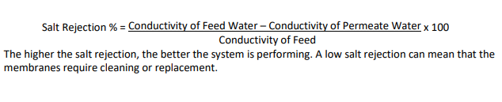

**Cut off distance**

To improve the computational efficiency, a cutoff distance is used in which the calculations are carried out